**Create a Adaptive Application**

* Firstly create one new project by clicking on file option on top-left corner and new ->project.

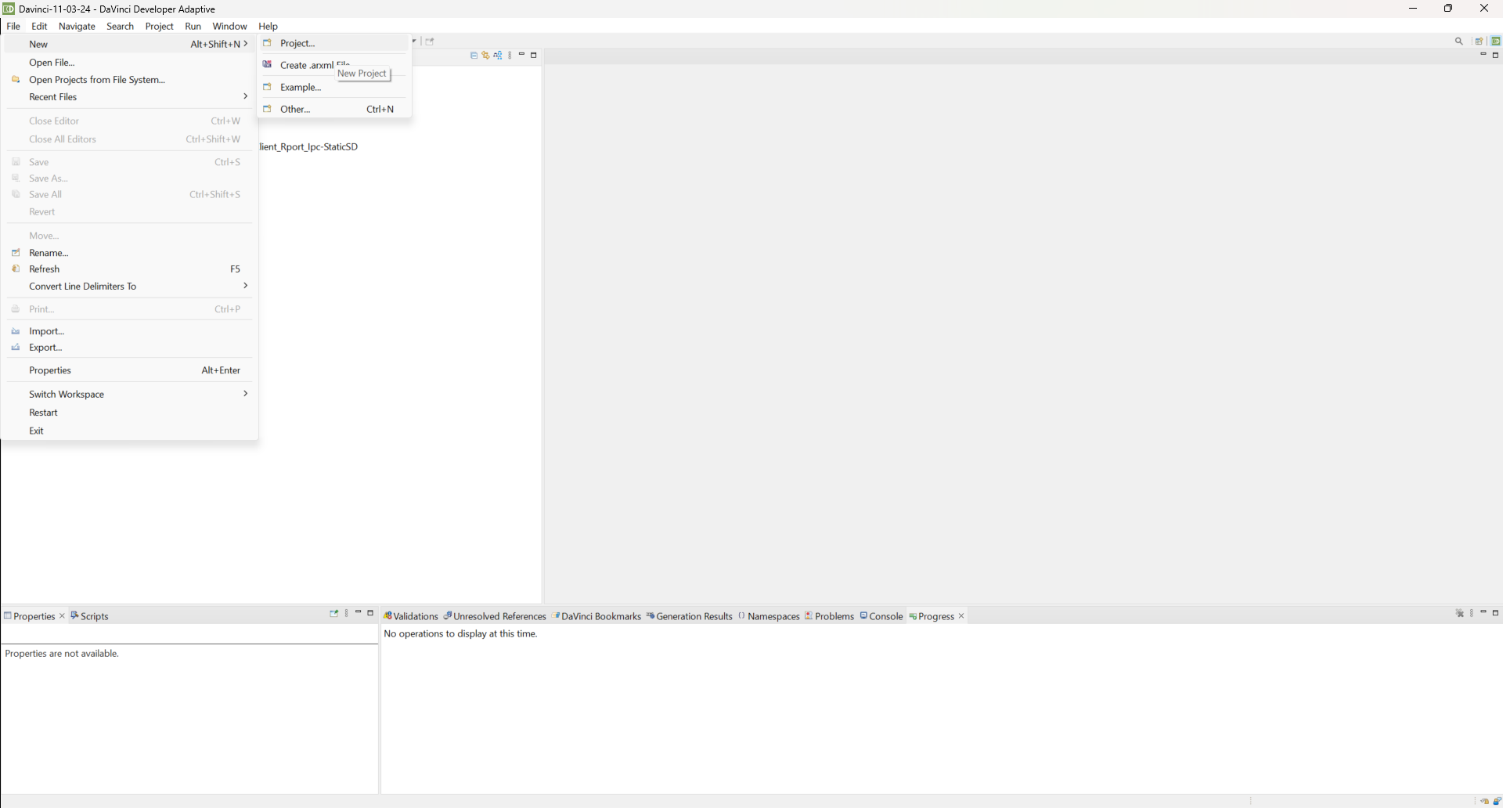

* Select Davinci Adaptive->Create DaVinci Adaptive Project, then click on next.

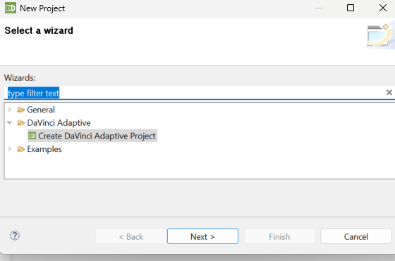

* Enter the Name of project and click on next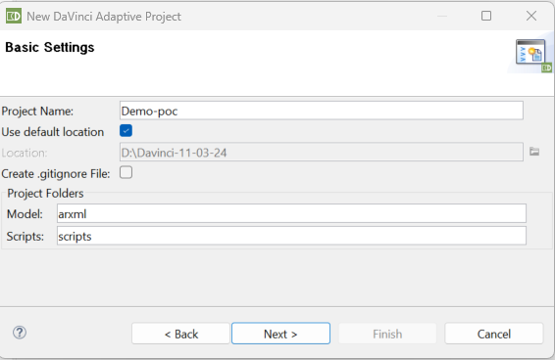
* In case you have any already existing project that you want to use as a reference for the current project you can select else you can directly click on next.

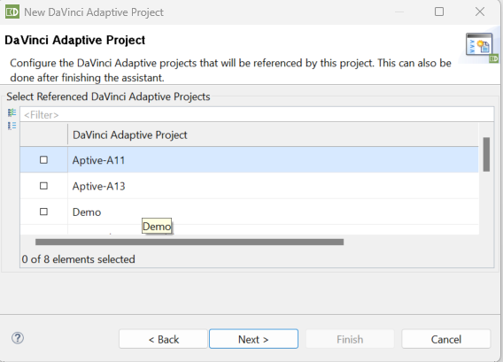

* In this window you must select the AUTOSAR Standard Types into project option and if you have any arxml’s that you want to include in this project you can include using + sign on left side else click on finish.

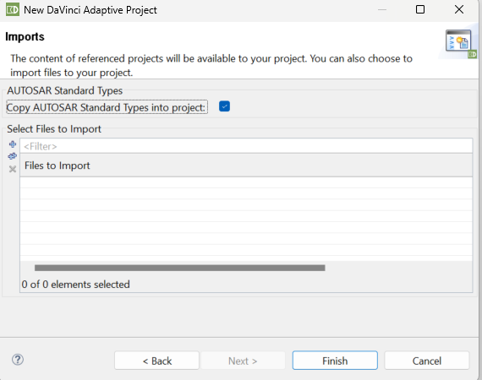

* Application Design-

Click on Open Project Dashboard under your project.

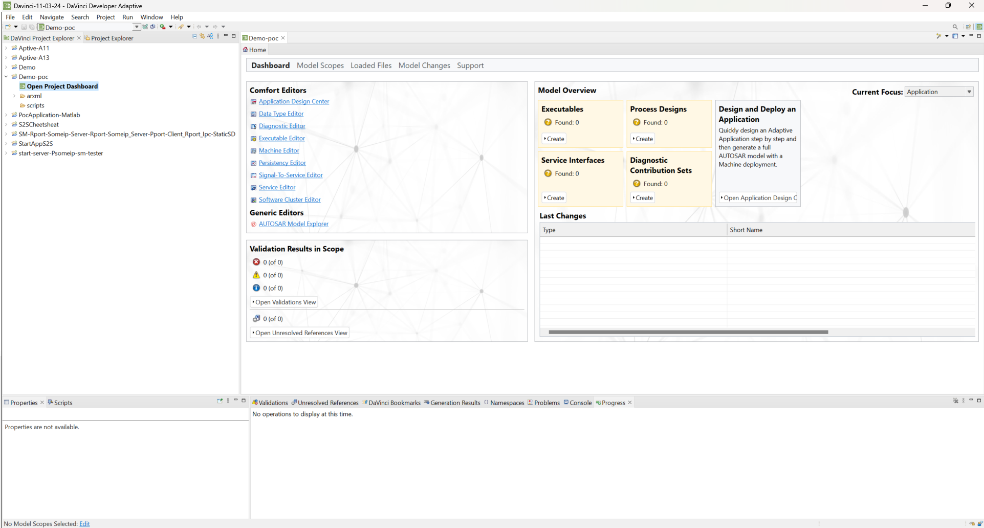

* Go to Executable Comfort Editor window. Click on [+] to create new Executable.

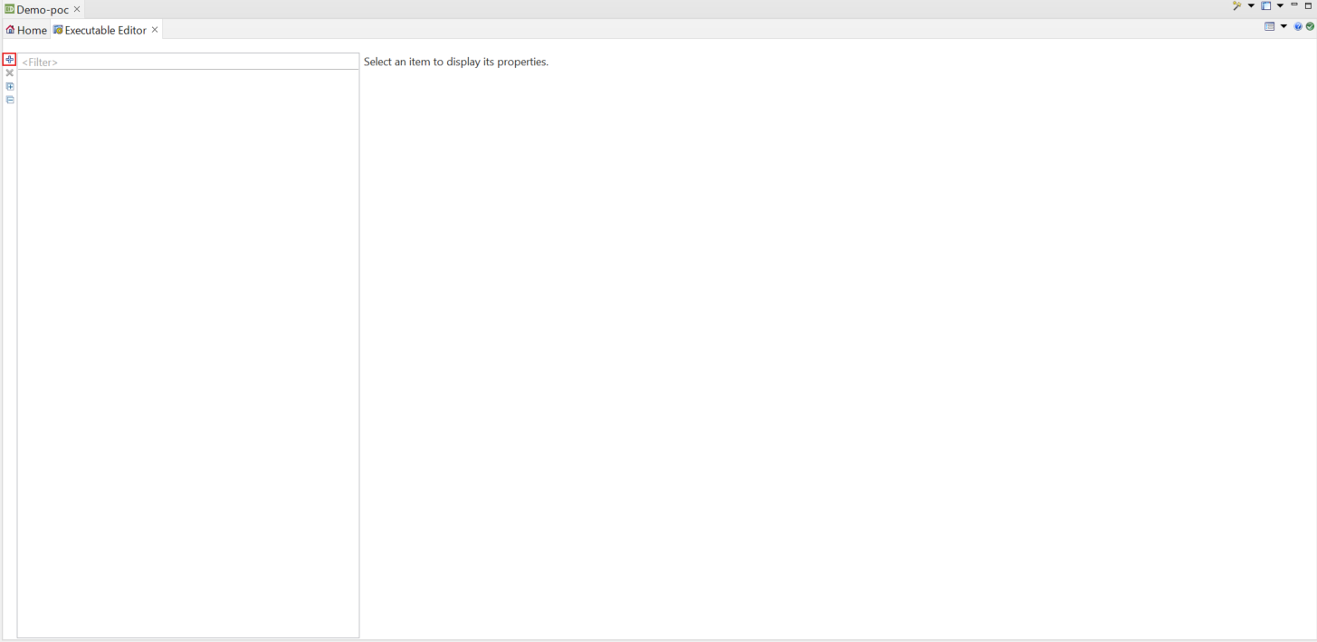

* In the [Create Executable wizard] window fill out
  + Name: ”DemoApplication”,
  + Click on [select Package Icon].

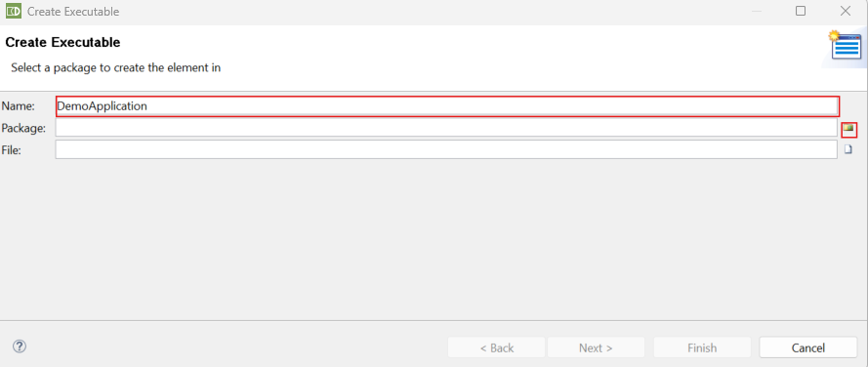

* In the [Package Selection] Window
  + Click on [+] to add a Package

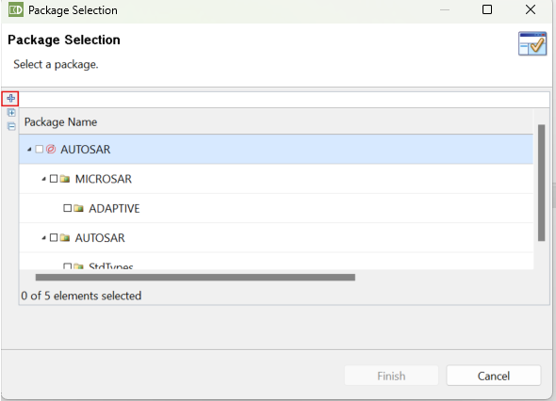

* In the [Add Package] Window.
  + Enter Name: “Demo”,
  + Click on[select File Icon]

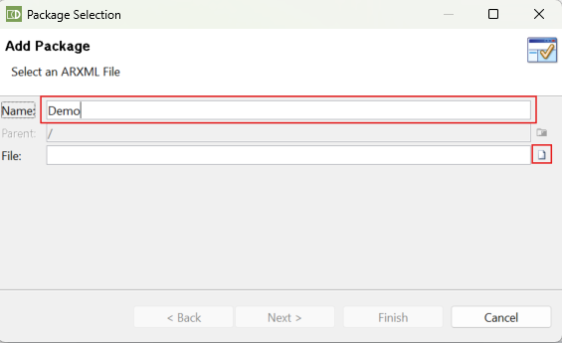

* In the [Select File] window.
  + Click on [+] to create a new File

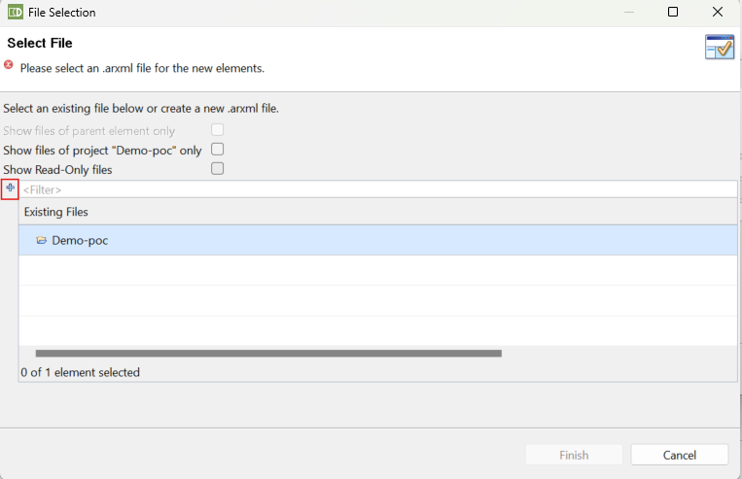

* In the [create .arxml File] window fill out
  + Name :”DemoExecutable.arxml”->[Finish].
* In the [File Selection] Window
  + Select the “DemoExecutale.arxml” file -> [finish].

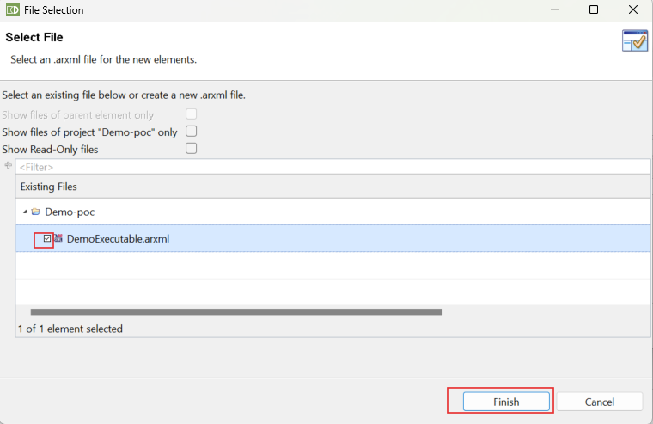

* In the [Add Package] window
  + Click on [finish]

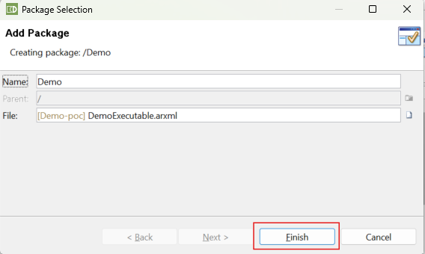

* In the [Package Selection] window
  + Select [Demo],
  + Click finish.

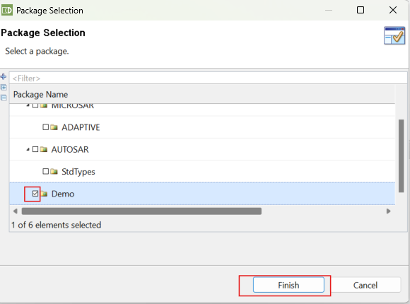

* If you want to create sub-package for the Demo you can directly type on the Package section. for eg. Currently we have Demo package under that we are creating subpackage for the executable like “/mydemoexecutable”.then click on [Next]

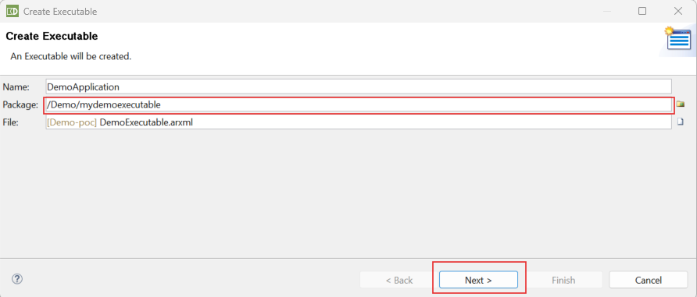

* In the [Select an Adaptive Application SW Component Type] window
  + Click on [+] to create a new Adaptive Application SW Component Type

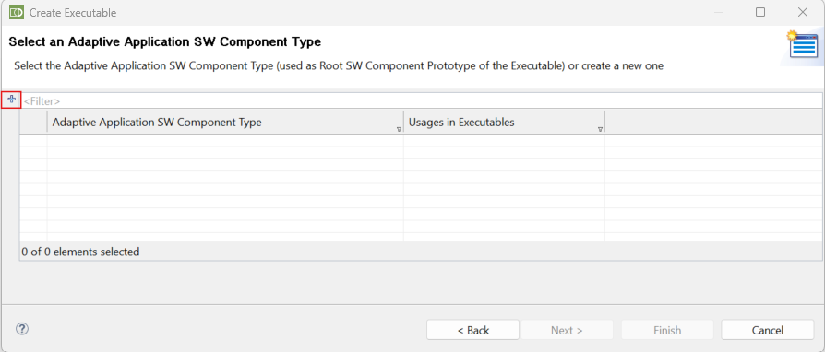

* In the [Create Adaptive Application SW Component Type ] window
  + Enter Name “demo_Component”->[Finish].

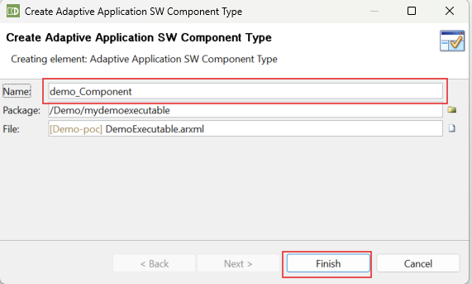

* In the [Select an Adaptive Application SW Component Type] window
  + Select “demo_Component”->[Finish]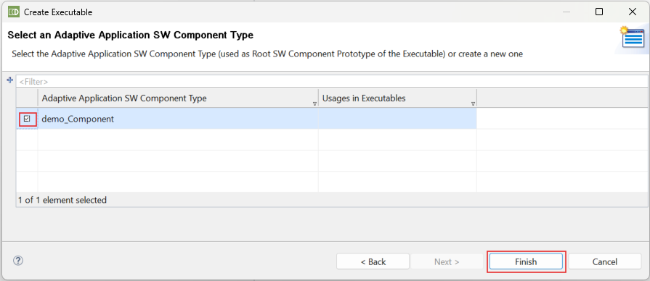
* Machine Design-

Go to Machine Comfort Editor window. Click on [+] to create new Machine.

* In the [Create Machine] window ,fill out
  + Name : “demo_machine”->Click on the [Select package Icon]

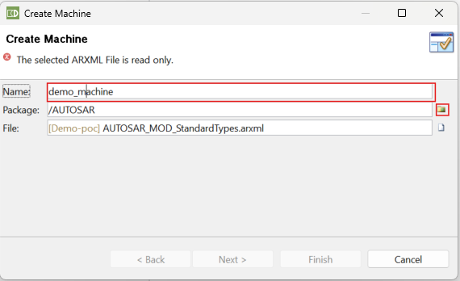

* In the[Package Slection]
  + Select “Demo” and Click on the [+].

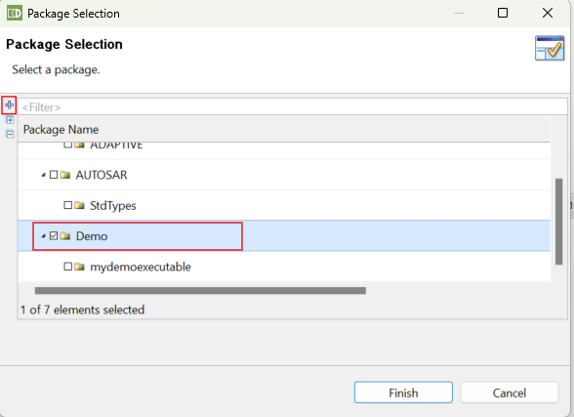

* In the [Add Package] window
  + Name:”demoMachines” ->Click on the [Select File Icon]

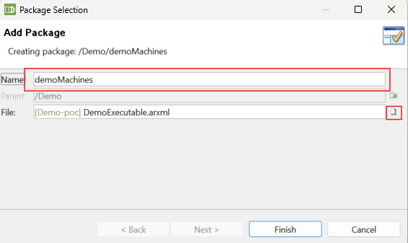

* In the[File Selection] window
  + Click on the [+] to create a new file .

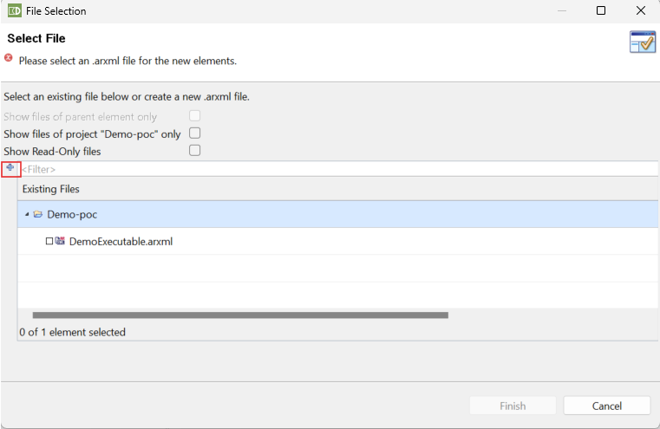

* In the [Create .arxml File] window,fill out
  + “DemoMachines.arxml” ->click[Finish]
  + Select “DemoMachines.arxml” and click[Finish]

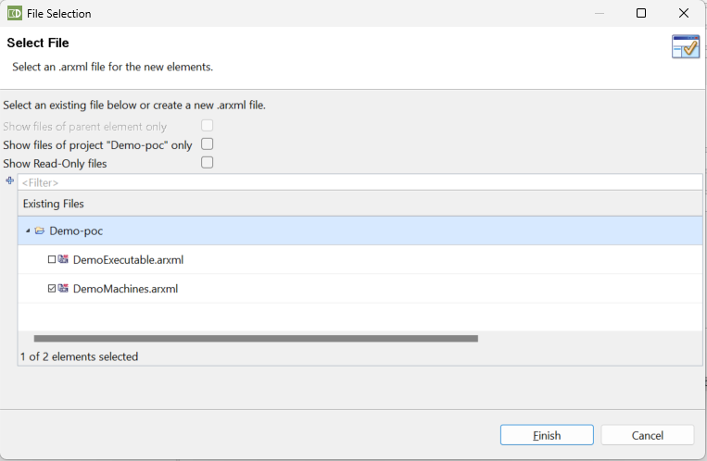

* In the [Add Package] window
  + Click on[Finish]

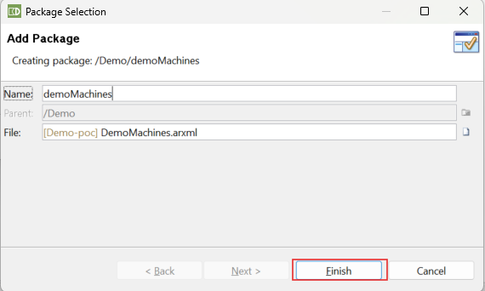

* In the[Package Selection] window
  + Select [DemoMachines] and Click on[Finish]
* In the [Create Machine] window,
  + Click on [File Selection]
  + Select “DemoMachines.arxml” and click on[Finish]
  + Click on [Next]
* In the [Machine Design] window,
  + Click on [+] to create a new Machine Design

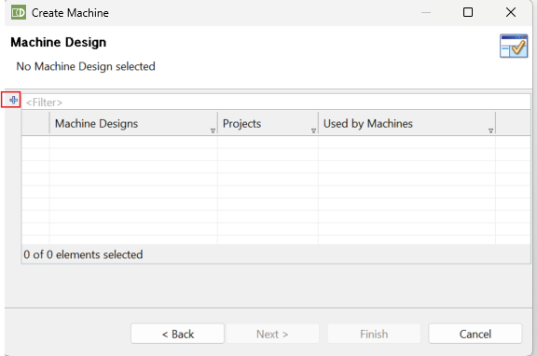

* In the [Create Machine Design] window ,fill out
  + Name : “demo_machine_design”
  + Create a new package and file “MyMachineDesigns”(only if you want creating the new arxml files )

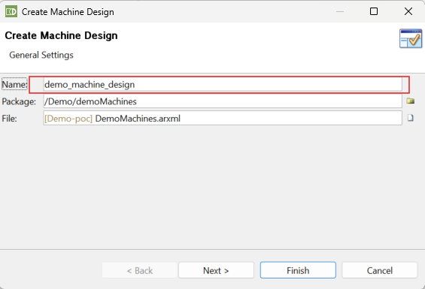

* In the [create Machine Design] window,
  + Select the new machine design and click on [Finish]

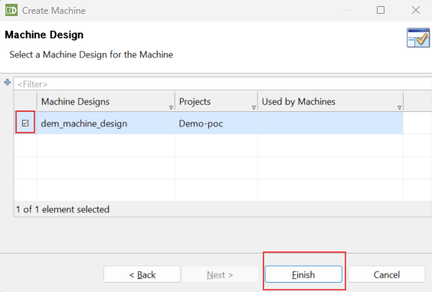

* In the [Machine Comfort Editor] click [+] under Network Settings.

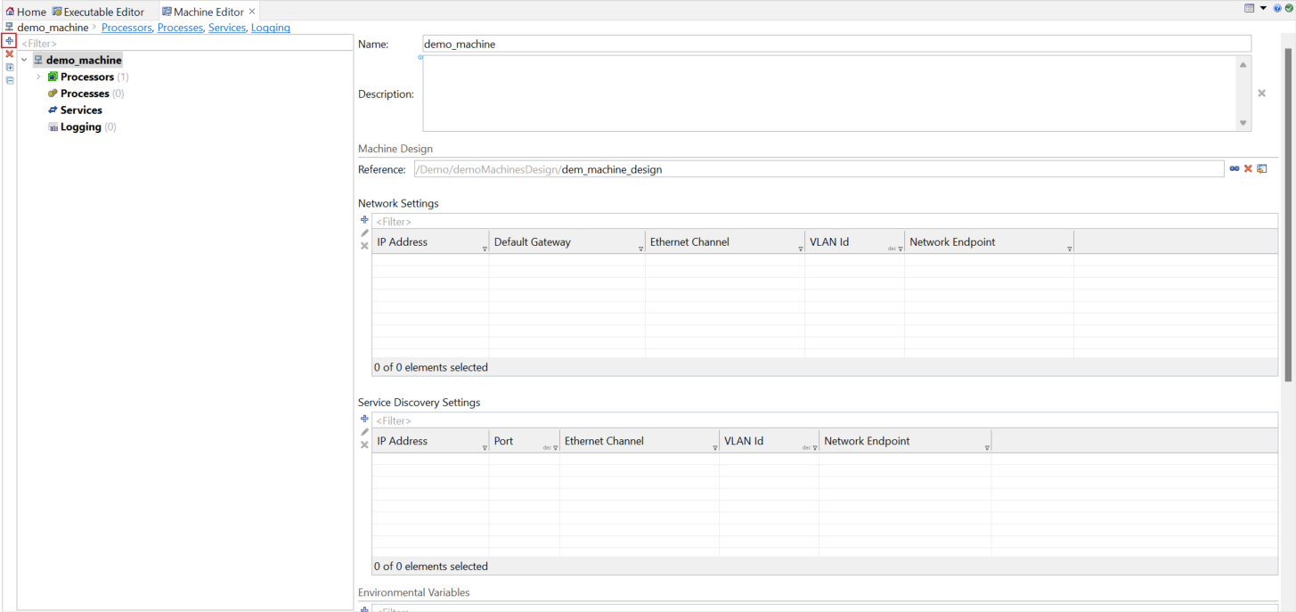

* In the [Create Network Endpoint]Window click on [+]

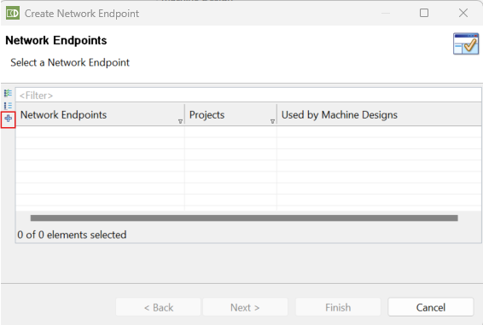

* In the [Ethernet physical channel]Window click on [+]

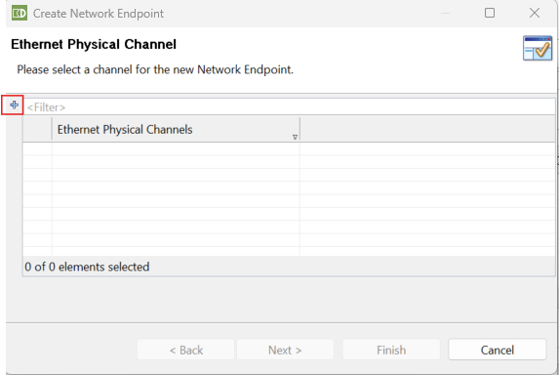

* In the[Create Ethernet Physical Channel] window ,fill out

Name:”demo_ethernet_channel”

Package:”Demo/demoMachinesDesign”

File:DemoMachines.arxml->Click on [Finish]

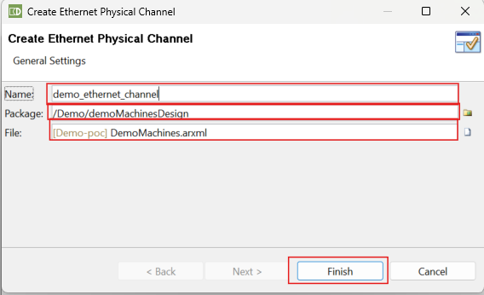

* Select the new demo_ethernet_channel ->Click [Next]

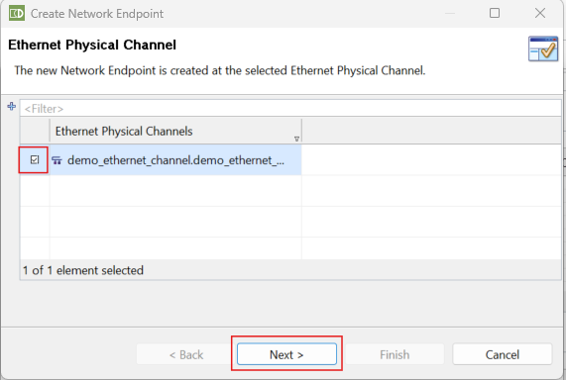

* In the [Add Network Endpoint] window fill out
  + Name:”demo_ethernet_network_endpoint”
  + Ip Address:”192.168.7.2”(ip address will be your interface ip that you want to give it to your machine)->[Finish].

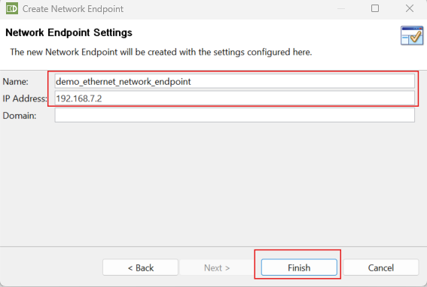

* In the [Network Endpoint] window click [Finish].

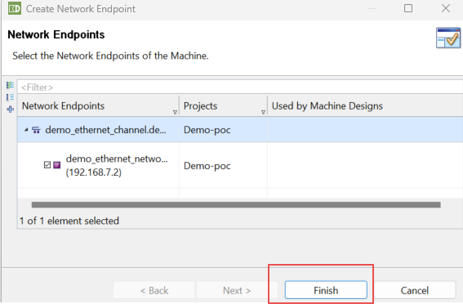

* In the [Machine Editor] click on the [+] below Service Discovery Settings.

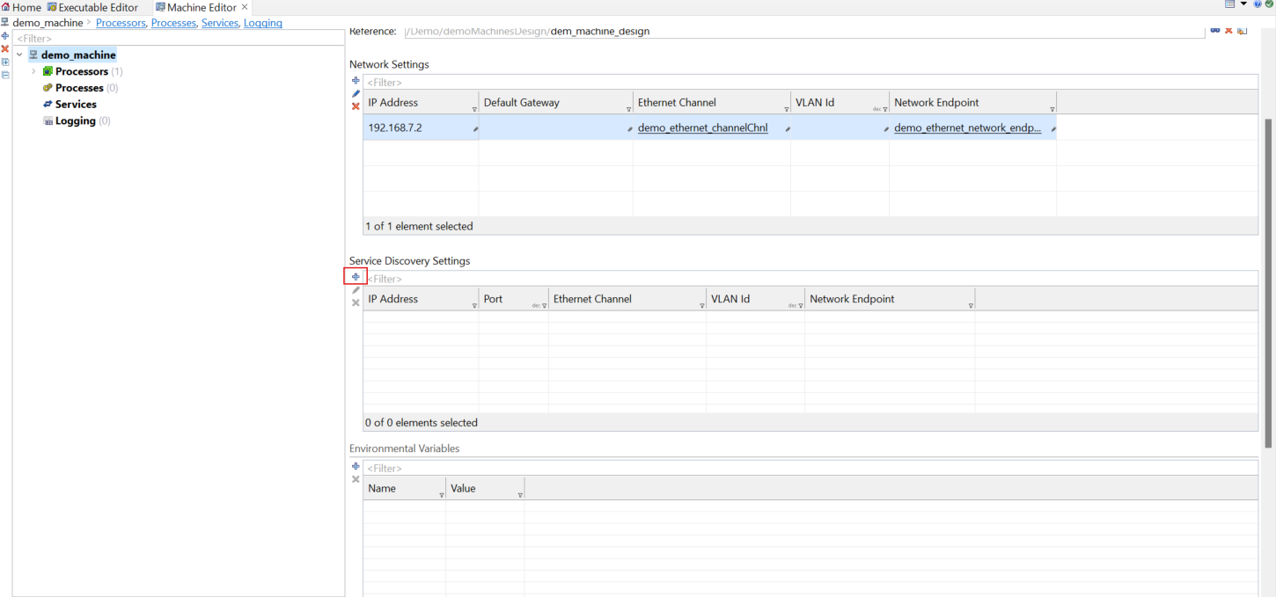

* In the [SOMEIP/IP Service Discovery] window click on [+] to create a new Endpoint

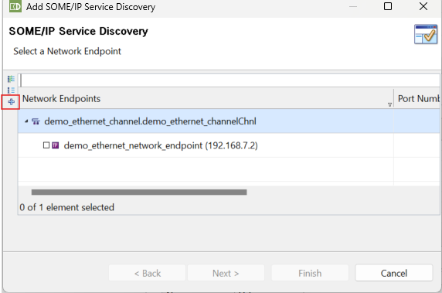

* Select the physical channel we already created -> click on [Next]

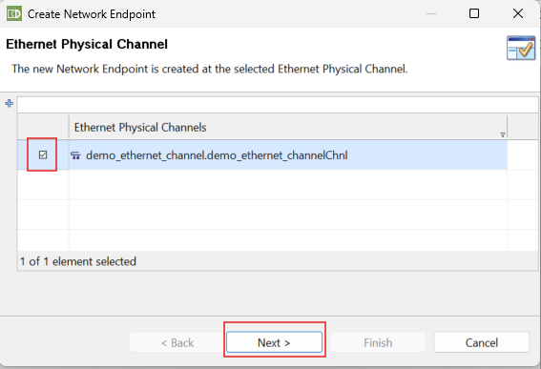

* In the [Network Endpoint Settings] window fill in,
  + Name:”demo_service_discovery_multicast_endpoint”
  + Ip Address: 224.0.0.17->Click on [Finish].

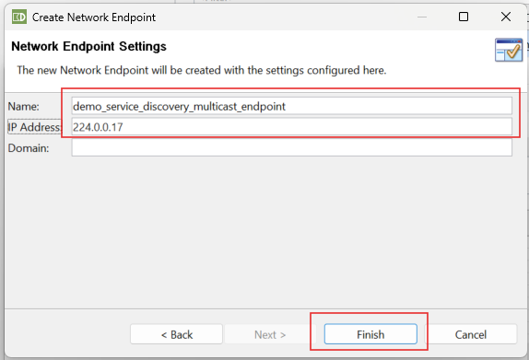

* In the [SOMEIP/IP Service Discovery] window,
  + Select the new created service discovery endpoint and change the port to 12330.click on [Finish].

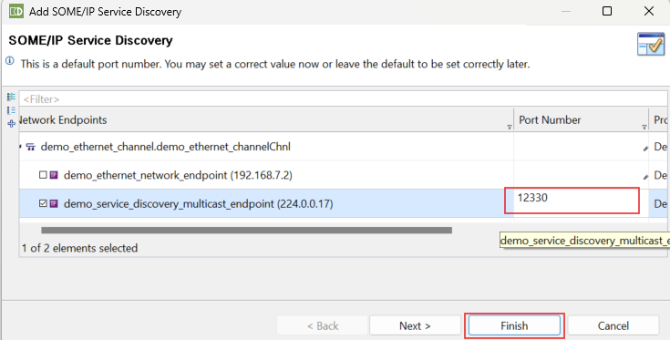

* Create new Function Group->Go to Software Cluster Editor [Comfort window] window
  + In the new Software Cluster Editor
    - Select [Function Group Sets] and click on [+]

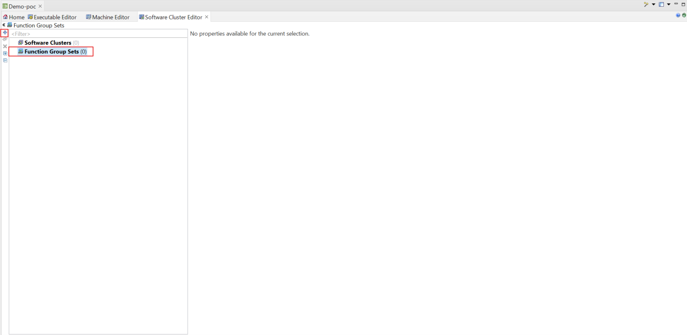

* In [Create Function Group Set] Window,fill out
  + Name:”demo_function_group_set”
  + Select Package:”/Demo/demoMachines” with “DemoMachines.arxml” file.
  + Click on [Finish].

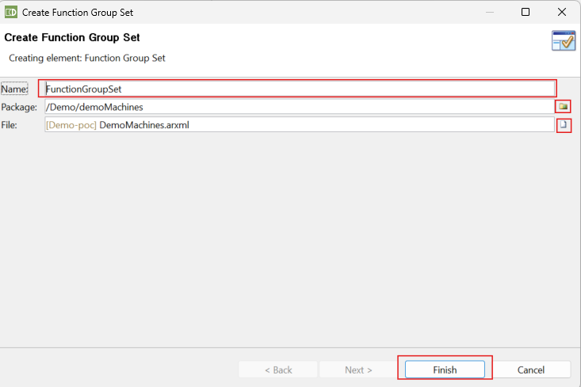

* In the new [demo_function_group_set]window,
  + Click on [+] to create a new function Group

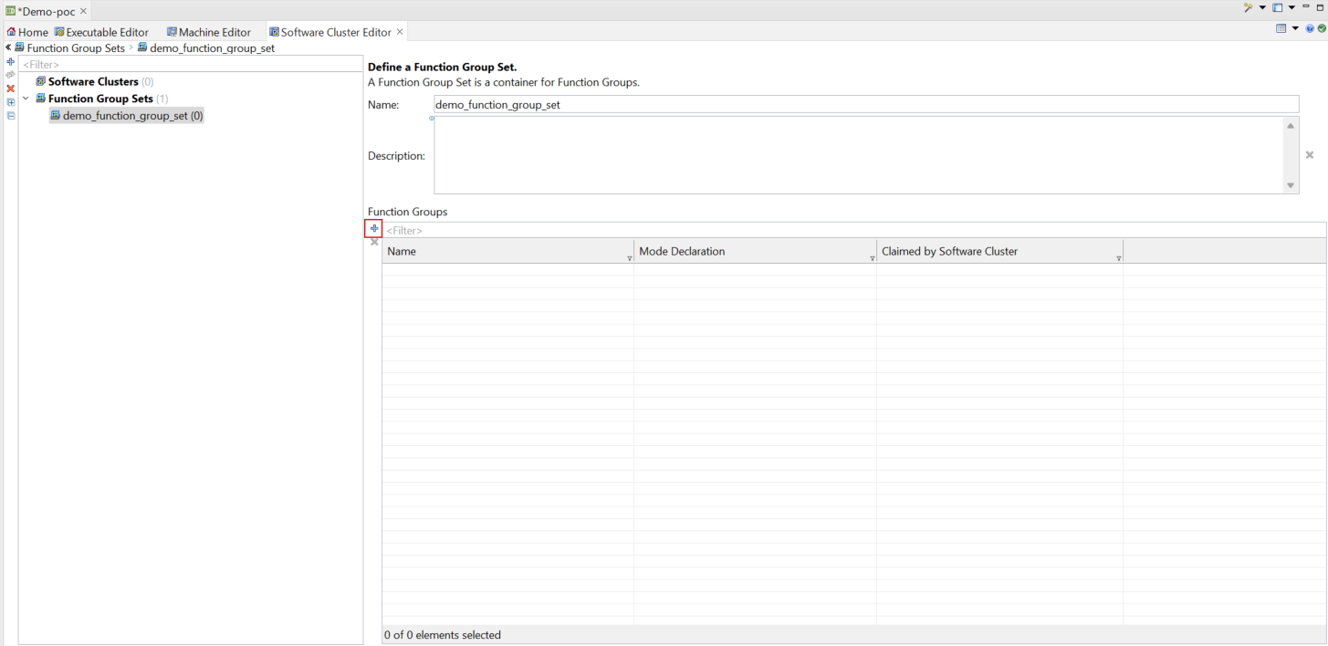

* In the [Create Mode Declartion Group Prototype] window,fill out
  + Click on Machine Function Group [tick](this will be your MachineFG)
  + Create a Package :”/Demo/demoMachines” with a “DemoMachines.arxml” file.

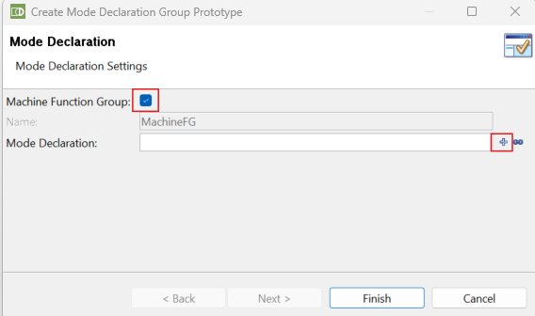

* In the [Create Machine State] window
  + Name:”demo_machine_states”
  + Click on the [+] to create a new Mode

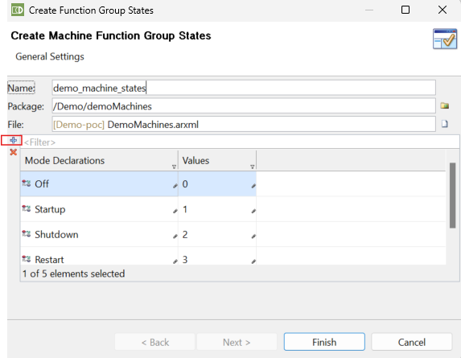

* In the [Create Machines State] window
  + Rename the new Mode to “Running” -> Click on [Finish]

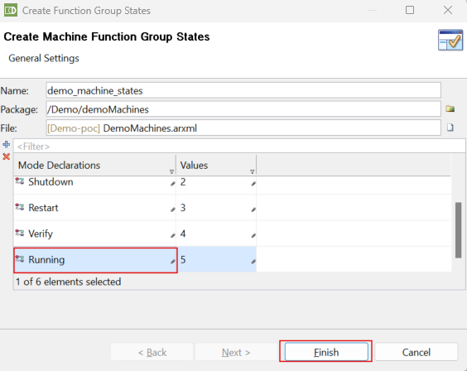

* In the [Create Mode Declaration Group Prototype] window,
  + Click on [Finish]

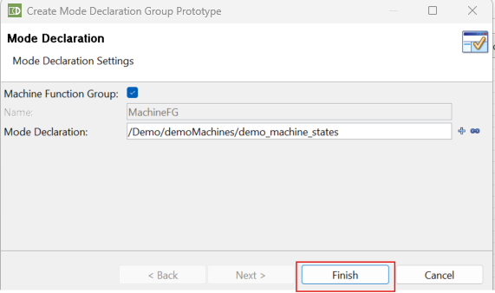

* Create a new Process->In the [Project Dashboard] in the [Processes] Section.
  + Click on [Create] to create a new Process

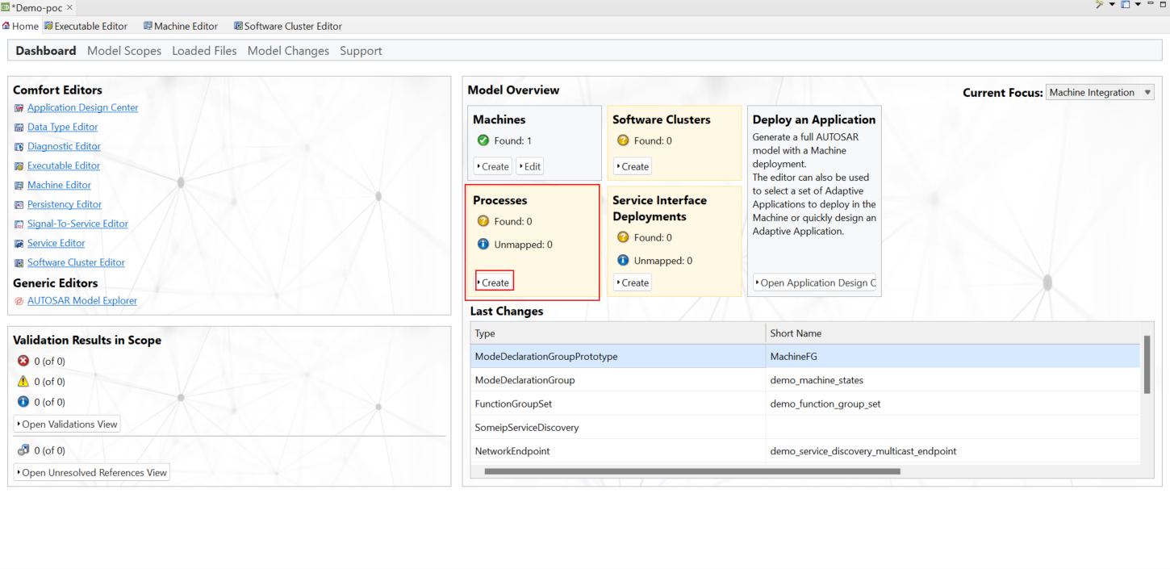

* In the [Create Process] window,fill out
  + Name:”demo_Process”,
  + Create new package and File:”/Demo/DemoApplicationDeployments”.
  + Click on [Next].

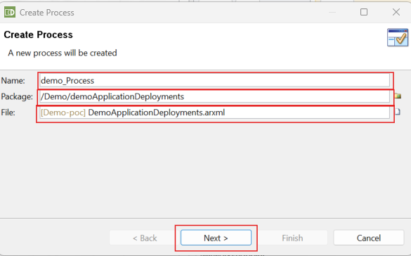

* In section [Select a Process Design] Click [Next]

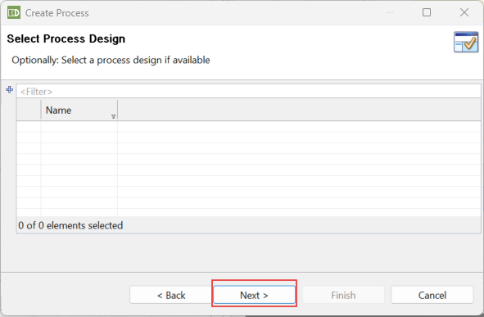

* In section [Select an Executable ] select out Executable ->Click [Next].

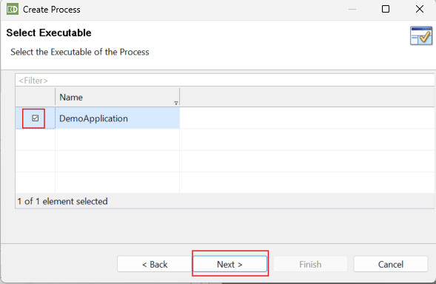

* In section [Select a Process State Machine] select our StateMachine->Click [Finish]

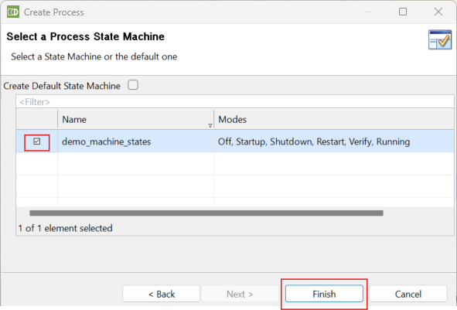

* In the [Machine Editor] Select the [Processes] settings
* Select our mapped process and click the [Map(Arrow)] button to map it to demo_machine.

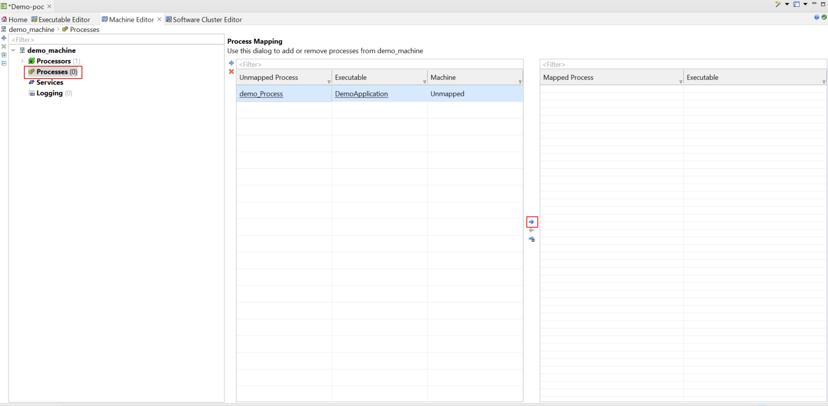

* There are 3 things are necessary for a process
  + StartupConfig to clarify the priority of our process when it is executaed by POSIX.
  + State Dependent Startup Config to clarify in which Machine State our process should be running.
  + In the Machine Editor View in Section [Processes] Click [demo_Process].
    - Then Click [+] in Startup Configuration

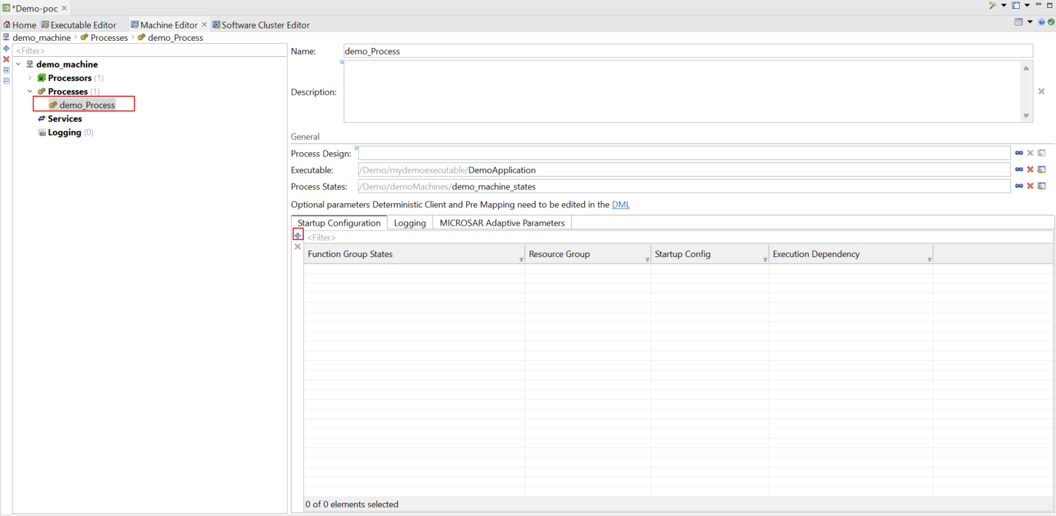

* Select the Function Group [MachineFG] and the Function Group State[Running].click on[Finish]

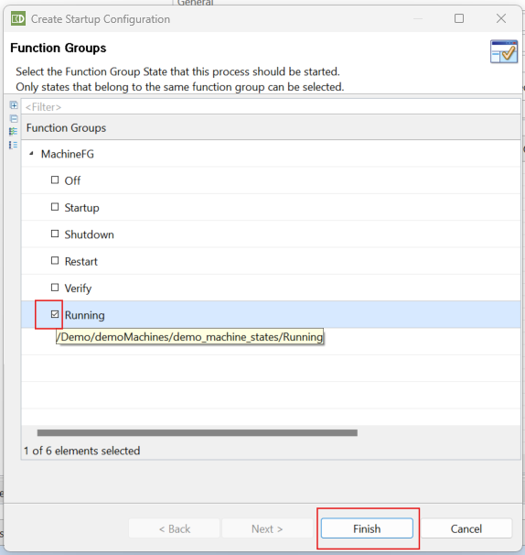

* In the [StartupConfiguration] Overview double-click on the empty [Startup Config] Field

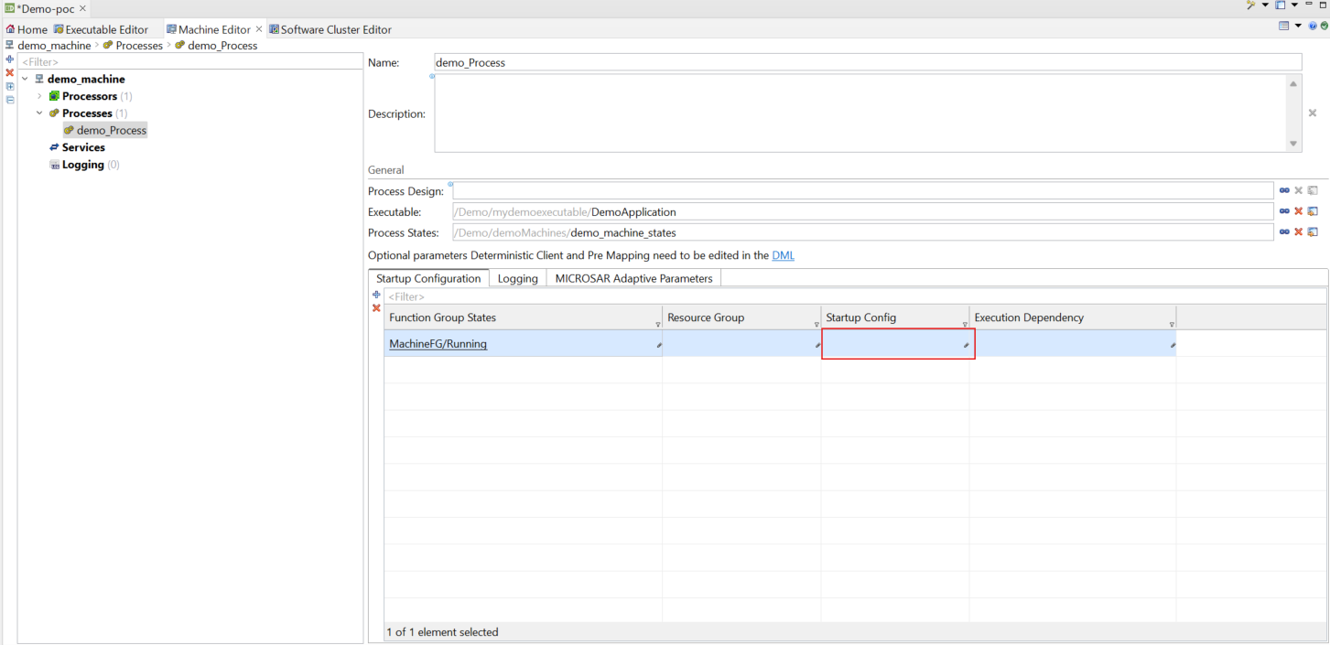

* In the Startup Parameters View Press on [+] to add a Startup Config Set,
* The new Startup Config Set should be:
  + Name:”demo_startup_config_set”
  + Package:”/Demo/DemoApplicationDeployments”
  + File:”DemoApplicationDeployments.arxml”->[Finish]

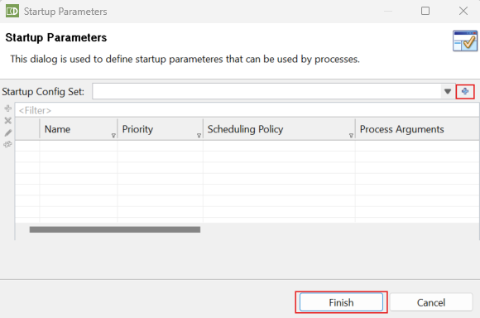

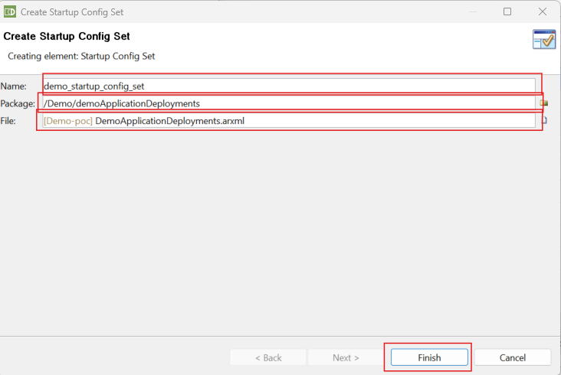

* Select the demo_startup_config_set.click on [+] to create a new Startup Config

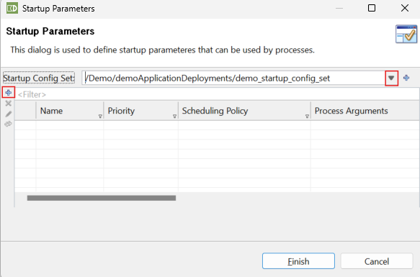

* Double-Click on the StartupConfig field to edit it

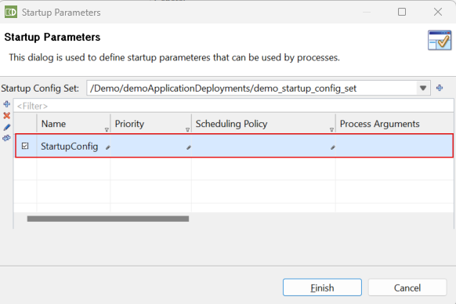

* Click on Name “Startup Config” and rename it to “demo_startup_config”
* Click on the priority Field:”20”
* Click on empty Scheduling Policy Field and choose the Round Robin Policy
* Click on [Finish]

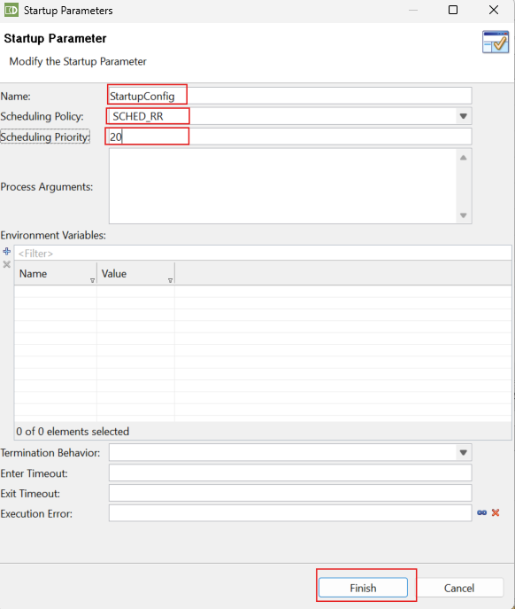

* Click on [Finish]
* In the Machine Editor go to Processors and click on the empty field of demo_core_0
* To select the core where demo_Process runs.

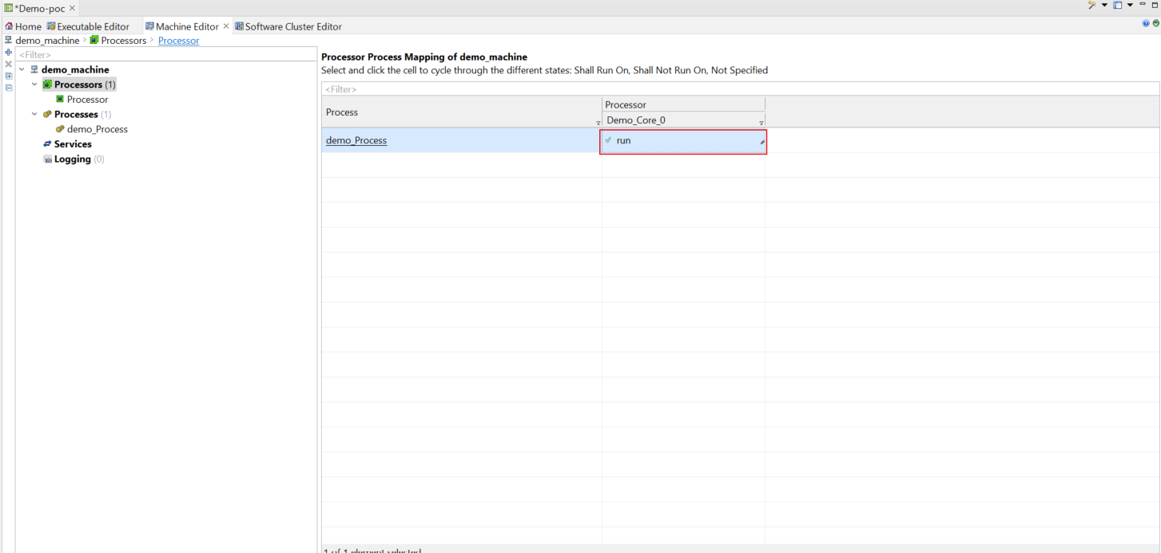

* On the [Dashboard] click on [create ] in the [Software Clusters] Section.

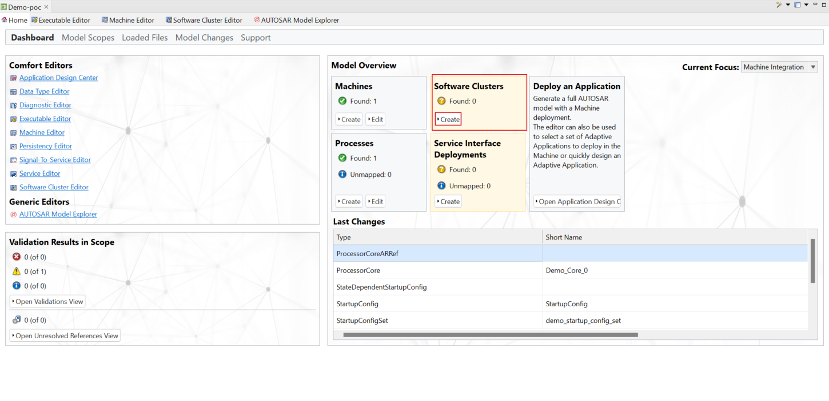

* In the [Create Software Cluster] Window,fill in
  + Name:”demo_software_cluster”,
  + Create a new Package and File :”/Demo/DemoSoftwareCluster”.->Click [Finish]

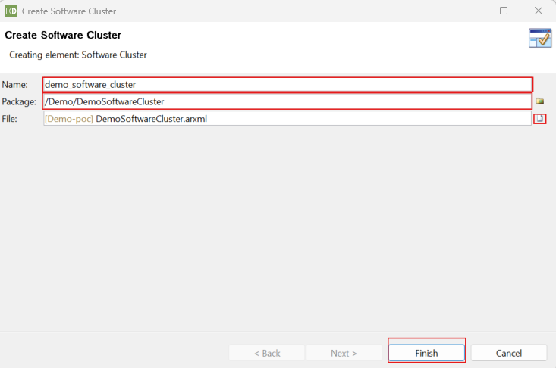

* Click [Edit] in the [Software Clusters] Section

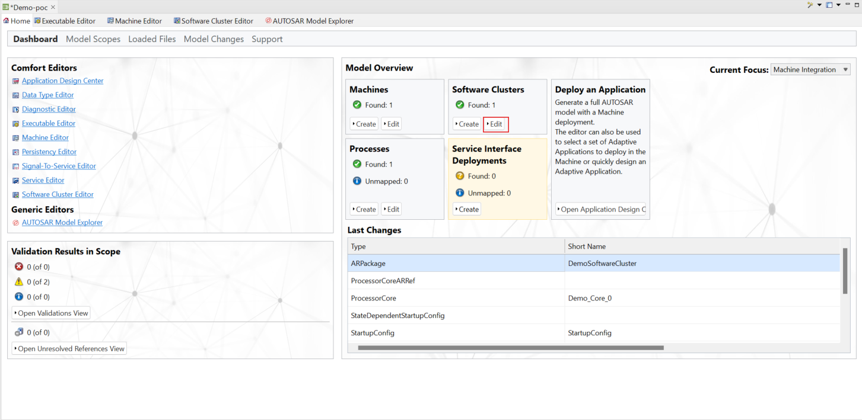

* Go to demo_software_cluster
* Software Cluster Category:PlATFORM_CORE
* Select “demo_machine” as Target Machine
* Press [+] to claim the MachineFG as Function Group to this Software Cluster and select the function group and click on [Finish]

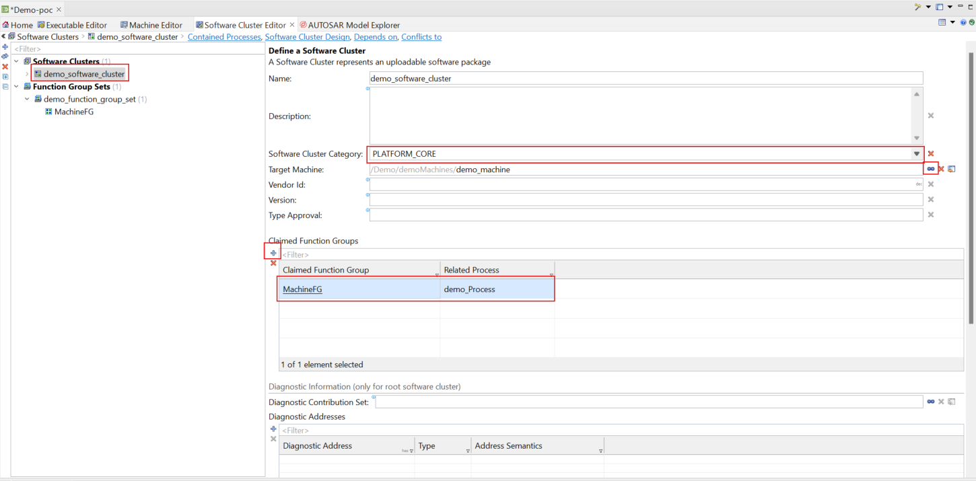

* Go to [demo_software_Cluster]->[Contained Processes]
  + Map demo_Process to this SoftwareCluster by pressing the [Arrow/Map] button

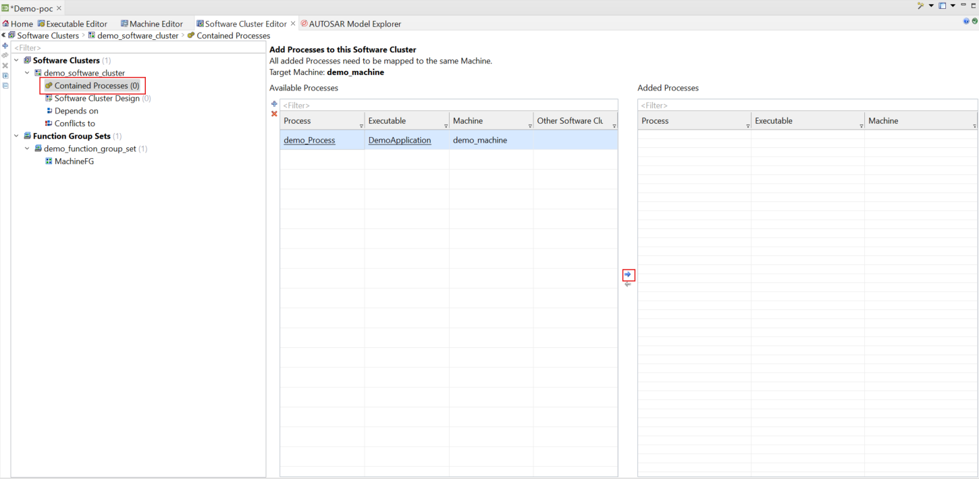

* To add the Logging Channel go to [Machine Editor] window
  + Click on Logging and then right-click on [+] to create a New Log and Trace Instantiation.

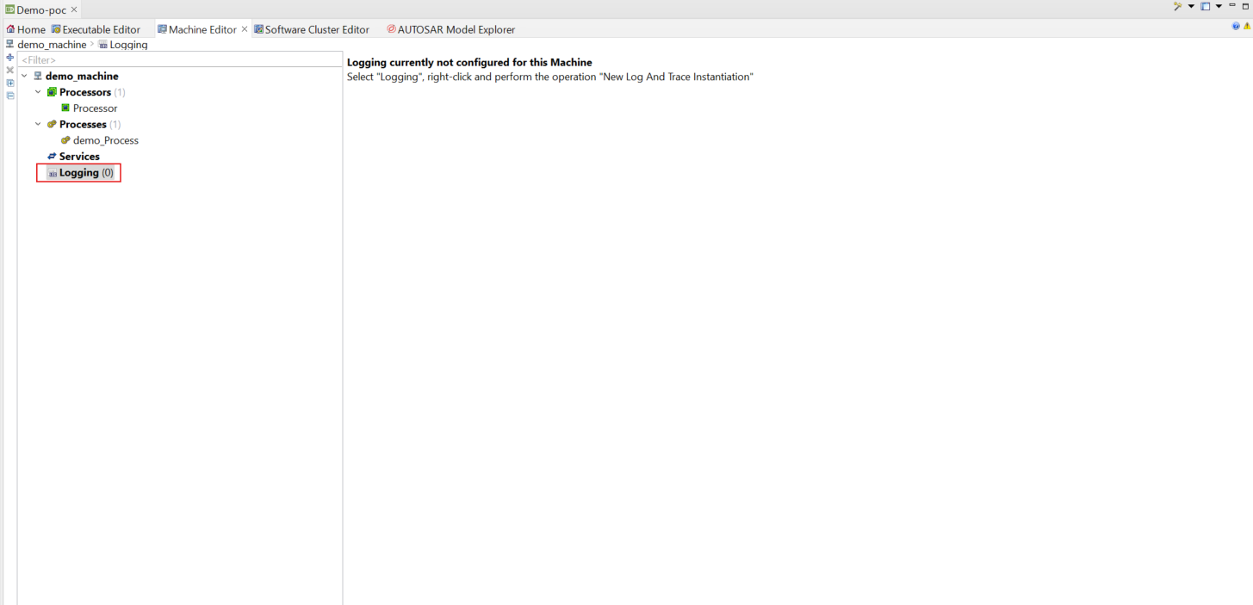

* On [Create Log And Trance Instatiation] window,fill out channel name”LogChannel”-> Click [OK]

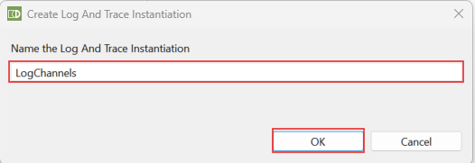

* On [Overview of the Log and Trace Instantiations] window
  + Click [+] to create DLTLogChannel

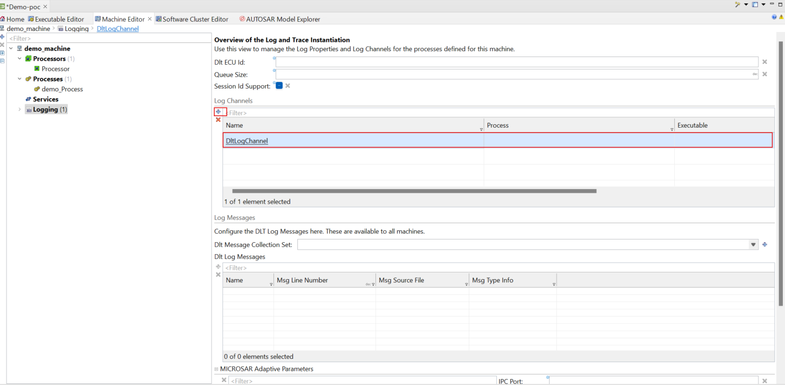

* Go to Log Channel Configuration and fill out
  + Name:”DltLogChannel”,
  + Application ID:”SERVER”,
  + Below [Log Configuration] ->[Logging Behaviour]
  + Select [Log Level]->INFO
  + Enable the Console [tick]

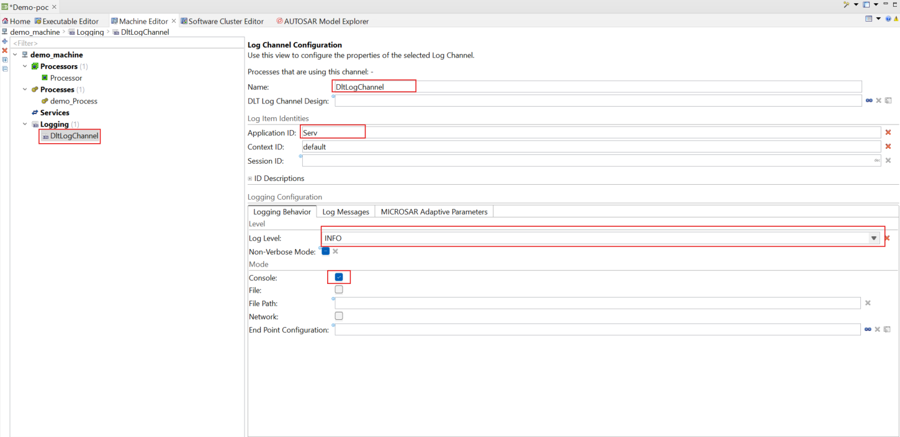

* In the Machine Editor View in Section [Processes] Click [demo_Process].
  + - Then Click [+] in Logging

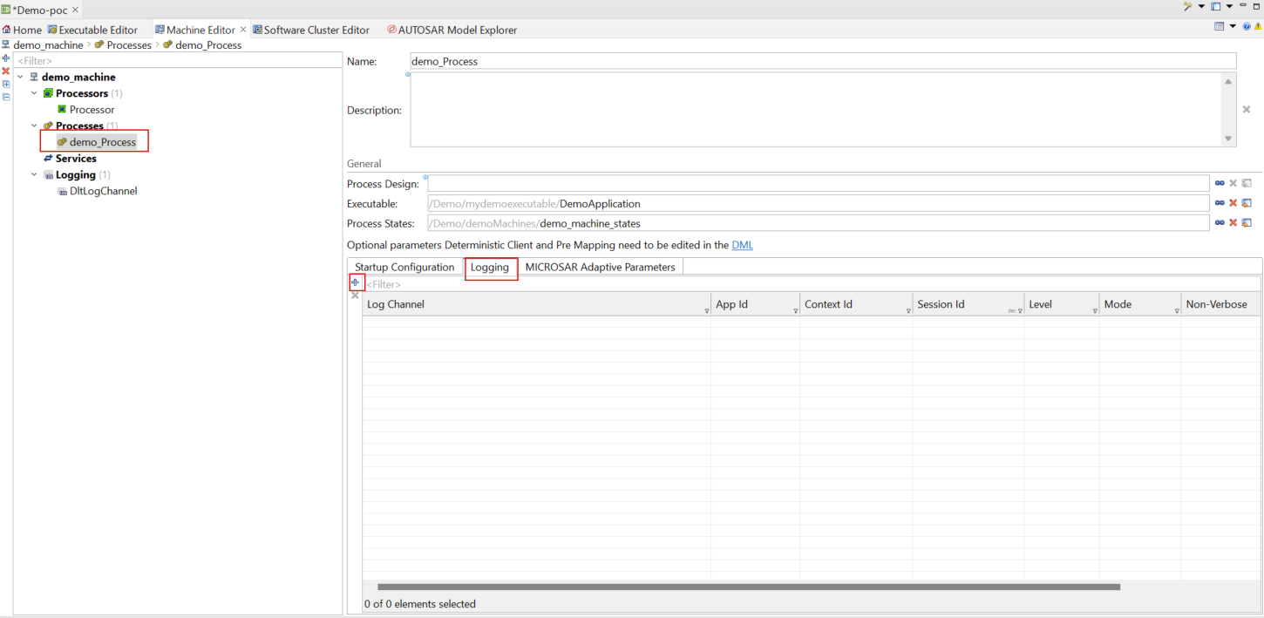

* In [Map Log Channels] window,
  + Select the log channel ,select package and file->click [Finish]

